# 1. Git-HOL

I learned the following in this hands-on lab:

- Familiar with Git commands like git init, git status, git add, git commit, git push, and git pull

- Setup Git configuration and integrate Notepad++ as default editor

- Add a file to source code repository

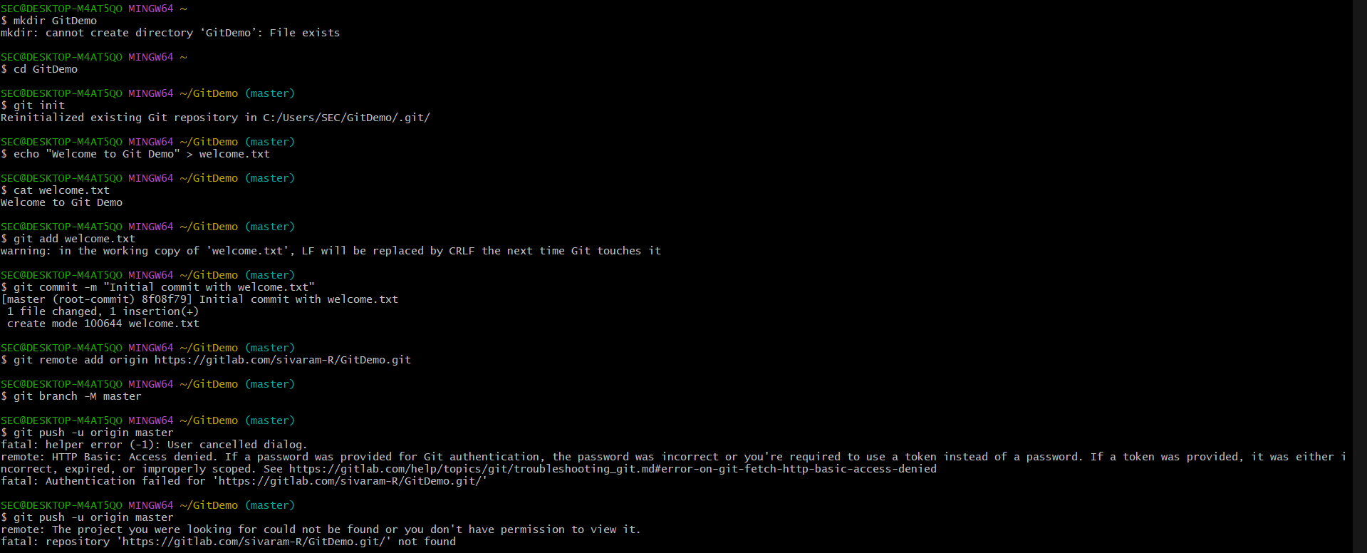

Summary of what I did:

Configured Git on Windows, integrated Notepad++ as the default editor, created a 'GitDemo' repository, added a welcome.txt file, committed it, and pushed it to the GitLab remote repository.